Design Patterns Identified

These are some of the design patterns that can be identified throughout the project.

Factory

1. src/main/java/org/jabref/model/entry/field/FieldFactory.java

This class hides the logic of creating a Field or set of Fields by providing a single access point for their creation.

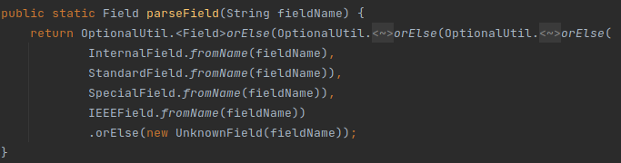Figure 1: Creating a single field from its name
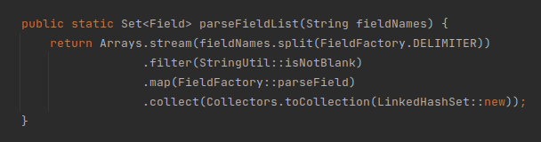Figure 2: Creating multiple fields from their name

2. src/main/java/org/jabref/model/entry/types/EntryTypeFactory.java

This class hides the logic of creating an EntryType by allowing the user to create one from a single String.
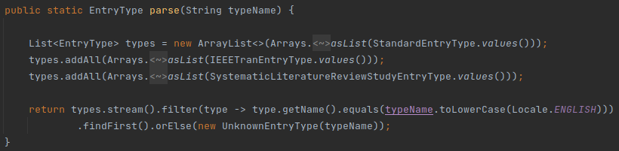Figure 3: Create a single EntryType from its type name
3. java/org/jabref/gui/actions/ActionFactory.java

This class allows the user to create various JavaFX components associated with actions without having to worry about the actual process of creation or association.
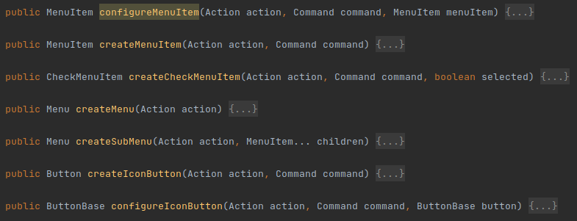Figure 4: Methods for creating different JavaFX components associated with actions
Strategy

1. src/main/java/org/jabref/gui/autocompleter

The AutoCompletionStrategy provides a template for solving an auto completion problem.
In this package we can also find problem solvers, like AppendWordsStrategy, AppendPersonNamesStrategy and ReplaceStrategy.
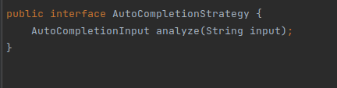Figure 5: Template for a problem solver algorithm
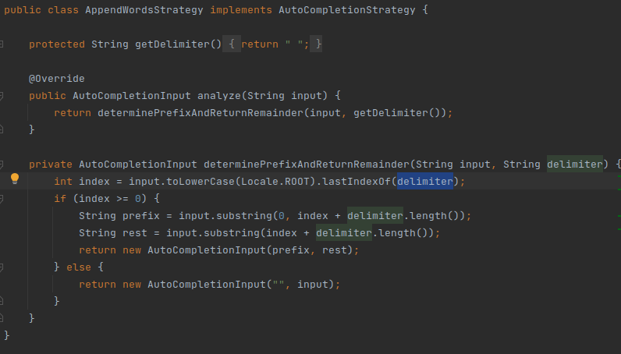Figure 6: AppendWordsStrategy, an algorithm to solve the problem
Proxy

1. java/org/jabref/logic/bst/PurifyFunction.java

This class only does error checking and the actual work is done by BibtexPurify. This is a protection proxy.
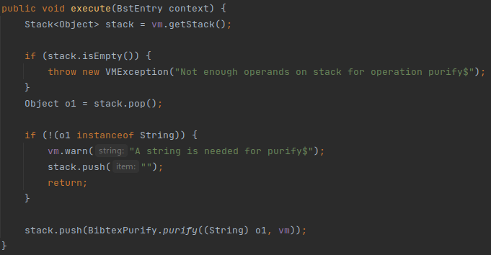Figure 7: Protecting BibtexPurify from receiving invalid arguments
2. java/org/jabref/logic/citationstyle/CitationStyleGenerator.java

This class provides a protection proxy to a CLS_ADAPTER by protecting the user from uncatched exceptions.
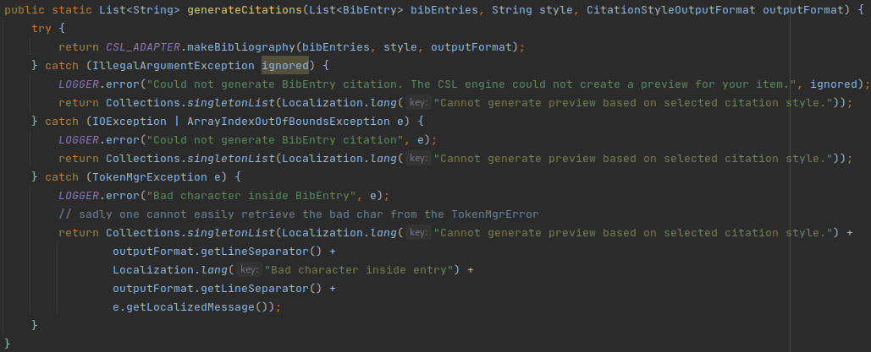Figure 8: Protecting the user from un-handled exceptions raised by the CLS
Singleton

1. java/org/jabref/logic/logging/LogMessages.java

This class provides a single access point, through the static method getInstance(), for the instance where error messages are stored.
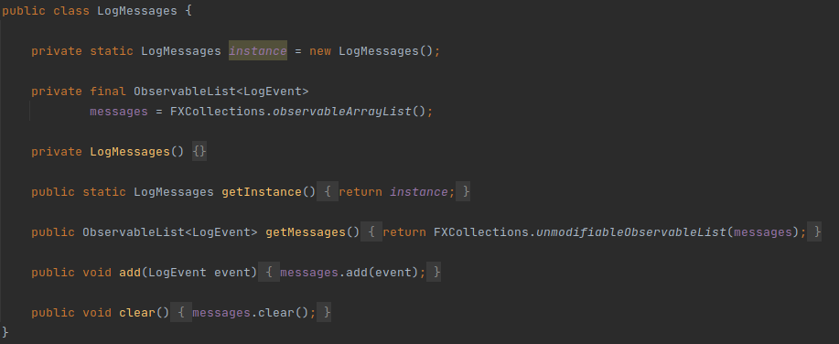Figure 9: LogMessages.java
2. java/org/jabref/preferences/JabRefPreferences.java

This class provides a global access point to a single instance, the constructor is private to ensure there is only one instance is created.
Figure 10: The only instance of JabRefPreferences

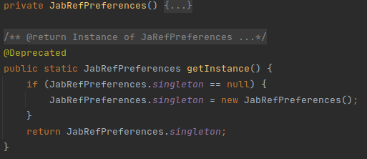Figure 11: Ensuring there only exists one instance

3. java/org/jabref/gui/externalfiletype/ExternalFileTypes.java

This class provides access to the available external file types.
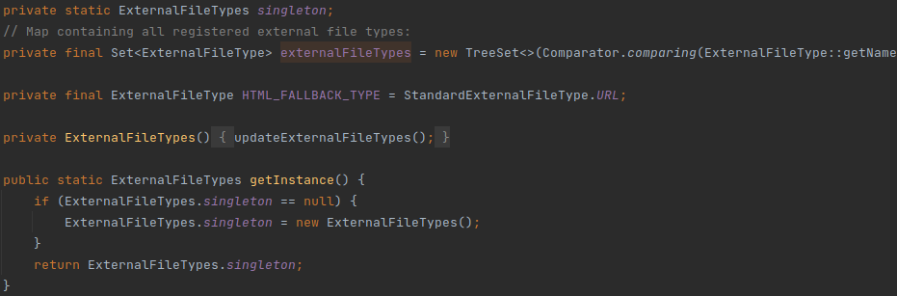Figure 12: ExternalFileTypes.java
Observer

1. java/org/jabref/model/model/database

The BibDatabase allows listeners to subscribe and unsubscribe from the eventBus, which acts like the Subject. In the same package KeyChangeListener represents the listener which gets notified of the events from the BibDatabase’s event bus and handles them accordingly.
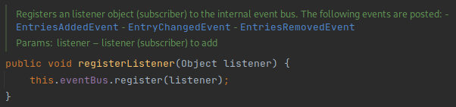Figure 13: BibDataBase.java registering listeners in the event bus
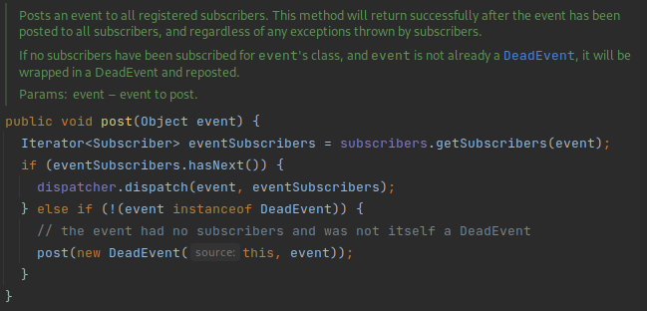Figure 14: EventBus.java forwarding the events to all the event subscribers

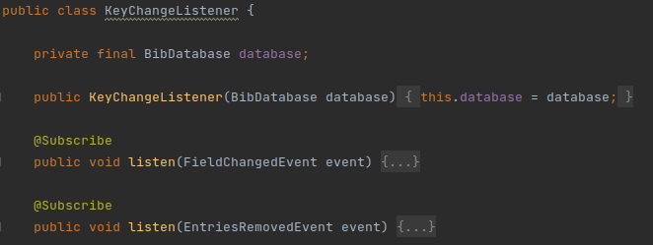Figure 15: KeyChangeListener.java listening for the events in the BibDatabase

2. src/main/java/org/jabref/model/util

The FileUpdateListener and FileUpdateMonitor match the observer and subject, respectively.
We can add and remove new observers by calling addListenerForFile(…) and removeListener(…) in the subject. The observer gets updated through the fileUpdated() method.
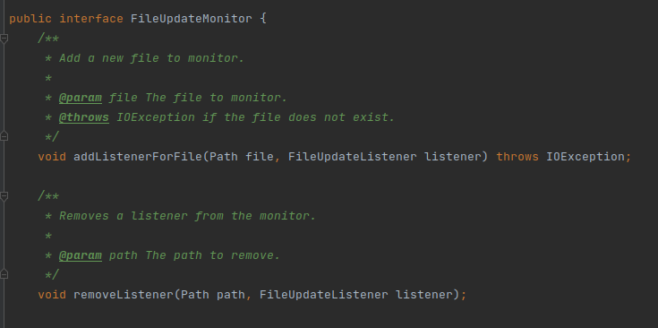Figure 16: FileUpdateMonitor.java registering listeners
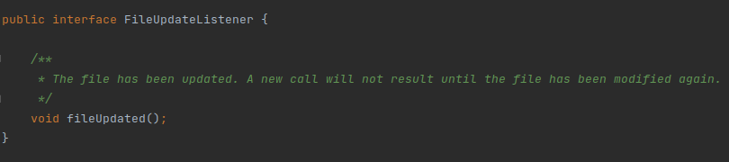Figure 17: FileUpdateListener

Builder

1. java/org/jabref/model/entry/BibEntryTypeBuilder.java

This class lets the user create a BibEntryType step-by-step, with all the required details.
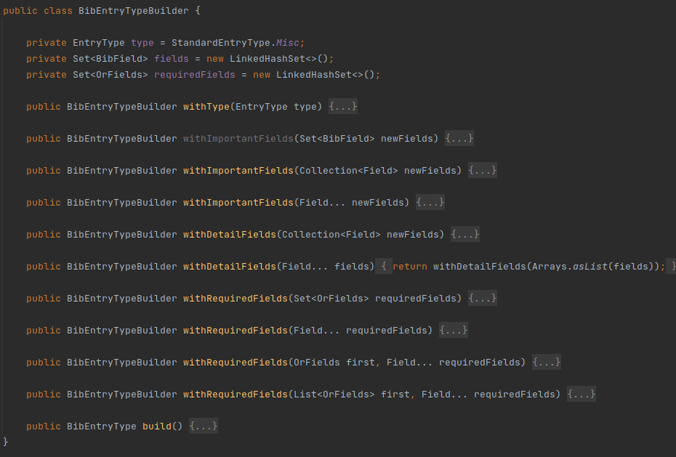Figure 18: BibEntryTypeBuilder.java
2. java/org/jabref/preferences/PreviewPreferences.java

This class allows the user to build a PreviewPreferences class step-by-step.
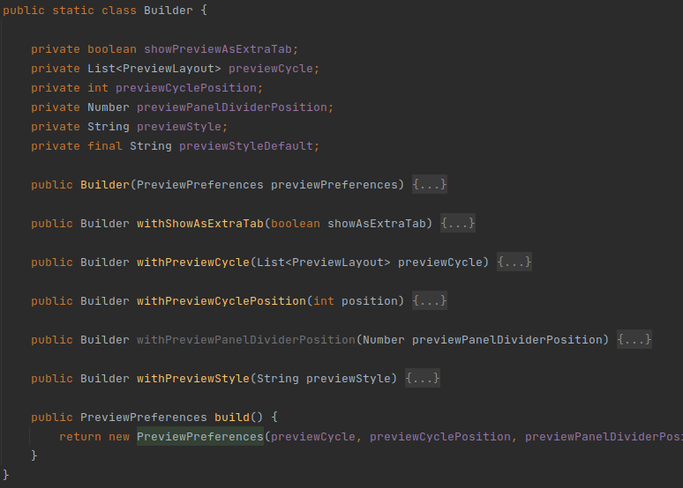Figure 19: PreviewPreferences.java

Facade

1. java/org/jabref/preferences/JabRefPreferences.java

Every preferece is stored inside JabRefPreferences which provides convenient access to a particular sub-preference. It knows where to direct the client’s request and how to operate.

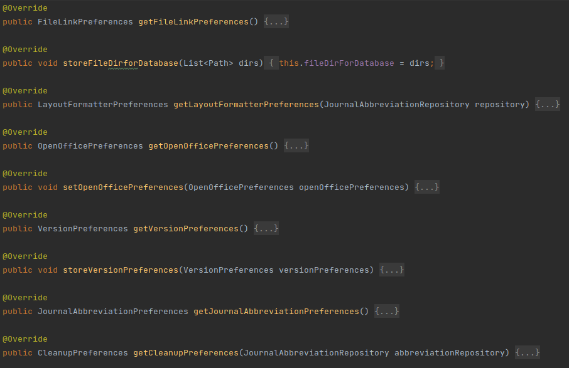Figure 20: Methods for acessing different preferences

Command

1. java/org/jabref/gui/actions/SimpleCommand.java

This class is an abstraction of a command that is executed by the actions of GUI elements, such as buttons. These actions provide normalized access to the Jabref low level functionalities.
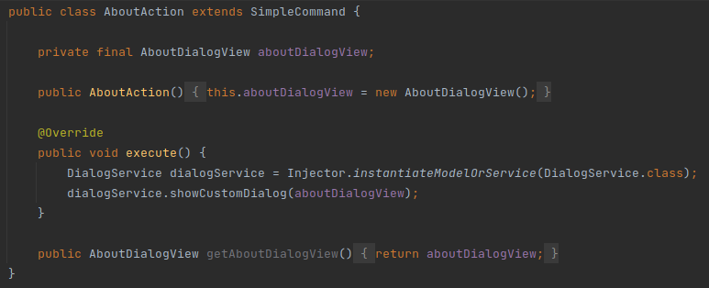Figure 21: An action

